THE EAST KESWICK PLATINUM JUBILEE QUIZ

Answers and additional information

A / 6 City Square
Perhaps in a nod to a more famous place the junction of Main Street and Moor Lane were known as “City Square” no doubt in reference to the busy hub in Leeds. It seems it wasn’t just the villagers who referred to it this way, even pre-war West Yorkshire bus timetables stated their stop in the village was City Square.

B / 2 The Duke of Wellington
This has been the site of a public house from the 18th century when it had its own brewhouse, stable and garden. This was one of two Inns in East Keswick given a license in 1777.
It was recorded as the “Wellington” in the 1822 Baines Directory, the earliest known trade directory to include East Keswick, and so must have been renamed in the years immediately following the battle of Waterloo.
In the middle of the 19th century George Moon, wheelwright and father of the successful East Keswick businessman, Henry Brewerton Moon, lived and worked here.
The Inn was surrounded by a complex of cottages, barns, stables, and workshops which were partly used by the Moon’s developing grocery business. These were eventually demolished to create the current car park and outdoor table area.

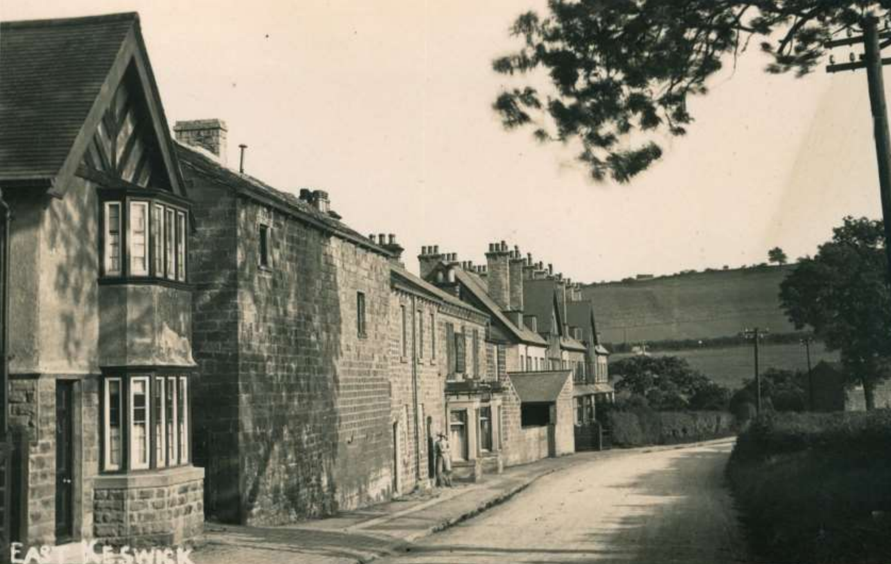

C / 5 The Old Star Inn
Like the Duke of Wellington, there has been a Public House on this site since at least the 18th century. The earliest mention of an Innkeeper in East Keswick is 1733.
The description from a village survey in 1796 states: ‘Public House, Barn, Stable and other buildings with fold and garden’; it most likely also served as a farmhouse.
The Old Star is also mentioned as a public house in the Baines Directory of 1822.
The 1851 census shows it was kept by Abraham Barrett whose occupation was given as innkeeper and butcher. He was later listed as a butcher and farmer indicating the range jobs that villagers undertook.
In 1899 the owner, David Midgeley, sold the Old Star to Tadcaster Brewery.
In 2001 East Keswick was the northern regional winner of the Village of the year and subsequently in 2003 the Prince of Wales toured the village, notably the ancient woodlands managed by the Wildlife Trust, but also found time to chat with locals in the Old Star.
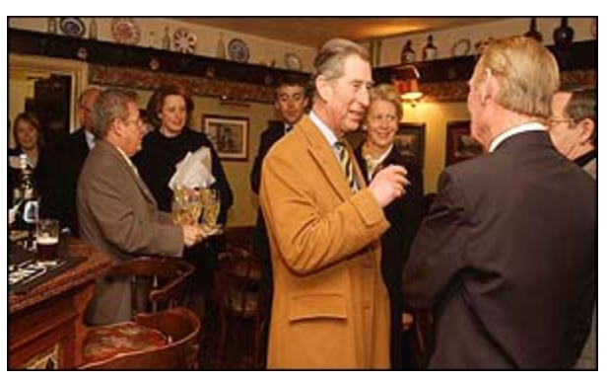

D / 3 Moon’s Grocery

Henry Brewerton Moon started a grocery business in the “West End” of Moor Lane, East Keswick in 1844 and, through a combination of successful business and inheritance from judicious marriage, was able to build this imposing retail and warehouse space with high quality accommodation attached in 1862.
Henry’s son George inherited the business in 1872 and it continued to grow so by 1908 it had 12 branches supplied from this warehouse initially by a horse and dray and later by motorised vans.

The spacious south facing house which formed the domestic part of the property boasted ten bedrooms and an acre of garden
The Two world wars were a major impact on the business so by 1947 the moon family no longer owned or traded from the premises although it did continue as a grocery until around 1968.
The house and warehouse were converted to flats.

E / 4 The Old Mill

Methodist activity in East Keswick dates back to at least 1741 and it was this building that was erected as their first dedicated chapel in 1792. It stood next to the Laurence’s school and seminary. It was sold to George Moon in 1891 when worship transferred to the current Church on Main Street. Moon converted the building to a flour mill which it remained until 1916. He installed an oil engine to power it which led to a legal case with local residents who complained of the noise and smell.
The building served as a corned beef store during World War Two before becoming a private house in 1947.

F / 8 Dains Corner

This was the name given to the corner of Main Street and Lumby Lane after the Dains family who had shops on either side of the road selling a variety of goods. Joseph and Margaret Dains came to the village from Leeds around the start of World War One during which their 20-year-old son Herbert tragically lost his life. Herbert is remembered on the village war memorial as well as by one on the memorial lime trees.

G / 9 The former Men’s Institute.

This building was respectively the village school and the home of the head teacher prior to the school moving to School Lane in 1914 where it remained until it closed in 1990. This building then became the Men’s Institute offering facilities for darts, billiards and dominoes. It also formed the village library which was open on Thursday evenings. Although girls were allowed to choose books, if their choice was not considered suitable for under-sixteens it had to be changed for one that was. The club remained popular until it closed owing to “war circumstances” in September 1940. The Home Guard used the premises during the war’s darkest days. When it reopened in 1943 the annual subscription was three shillings (15p)

H / 7 The Old Parsonage

The right-hand wing of the large house opposite was originally Low Farm which dates from before the mid eighteenth century. One of nine listed buildings in the village, it is an interesting property which was originally thatched and is notable for its unusual five pane windows which are also to be found in Harewood.
It was extended to form a parsonage when the church was built in 1856 but apparently was never popular with the curates due to its size.
There is a dairy on the side of the house and a large barn in front.

I / 10 Pasture House Farm.
This was a farm in the eighteenth century. In the nineteenth century the 53-acre holding was run by the Clough family until 1880 but at this time and in subsequent years land was transferred to other farms until in 1927 the farmhouse and remaining land was incorporated into Manor House Farm on the opposite side of the road.
In 1950 all 170 acres of Manor House Farm was sold to the tenant JJ Dalby for £7,900 by the Harewood Estate as part of a major land sale that took place in 1950 and 1951 to cover death duties.

J / 1 Brooklands
Completed in 1903 this terrace of nine houses was built by George Moon. They were the first houses in the village with electricity which was probably generated by the oil engine at the flour mill, and which predated the first mains electricity supply to the village by over twenty years.
With indoor bathrooms and hot and cold running water, these modern properties were advertised to attract Leeds commuters using the nearby Bardsey station. In some of the advertisements the location in a ‘Remarkably heathy neighbourhood’ was the headline to attract those wishing to escape the polluted air of Leeds.

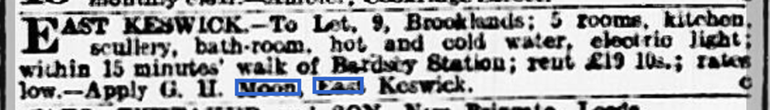

George Moon vociferously complained that the poor railway service was a deterrent to his ability to let the houses. That and the likely impact of World War One led to all the freehold being sold in July 1919.

The Moon family.

You will have noticed from these notes that the Moon family were very influential in the development of the village.

If you would like to learn more about the Moon family then you are welcome to attend our upcoming talks which will cover the rise and fall of their highly successful grocery empire, their influence on the East Keswick’s development and their fascinating life stories

10th November: The Moon Grocery Empire

8th December: You couldn’t make it Up: The secret family of Mary Moon

